Iconic Image
Impact Presentation and Argument w/Sources Essay

Learning Target
To respond to the AP mandate to incorporate "visual literacy" into the coursework

The Task
Select an arguably iconic graphic or visual image that has had a significant cultural impact. Do low intensity research to learn more about the historical context, origin, composition, production, manipulation, dissemination, and/ or subsequent alterations/ parodies of the chosen image. Using analysis and argument, explain how the image affected the social, political or cultural realities of its time and place. You will present your findings via presentation format to the class and you will write an argument with sources essay about the image you choose.

- A "visual image" could be a photograph, a painting, a statue, a commercial logo, a poster, or a monument. You must include the visual representation in both your presentation and essay.
- Your essay should have a main claim about the image (arguable), warrants from multiple resources, and an impact. MLA citations are required
- Your presentation should focus on the impact: include the effects of the visual image on its creator, on actual individuals it portrays, on short-term or long-term public perceptions of the event or issue it portrays ,on the political or cultural evolution of society following its appearance, on the subsequent development of the craft or art form, etc.

You should also include the answers to each of these questions in both your essay and presentation:
- What do you notice? Use the elements & principles to describe what you see. NOTE: you are not being asked to judge the work, only to explain what you see in the work.
- What does the work remind you of? Explain any stories, poems, memories, lyrics, etc. that come to mind when studying the work.
- What emotions do you feel as you engage with this work?
- What questions does the piece raise for you? What do you want to know?
- Speculate on the meaning, or the intent, of the artist. What do you think the artist was trying to convey? What was their message or purpose in creating this piece? List evidence seen in the work that supports your statement.
Examples:
Mount Rushmore's impact on American's view of history, on South Dakota's branding and
tourism, on American Indian attitudes toward the dominant culture
Dorothea Lange's Migrant Mother photo's impact on public response to the Depression, on
Lange's career, on the role of photojournalism, on Americans' view of their history
Picasso's Guernica's impact on immediate reactions to events of the Spanish civil war, on the
growth of cubism in modern art, on the tradition of political commentary by artists

1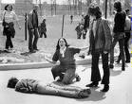 2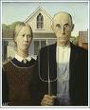 3 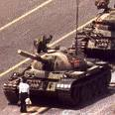 4

5 6 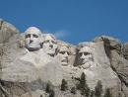 7 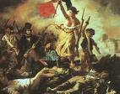 8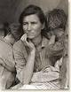
9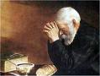 10 11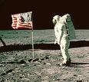12

1314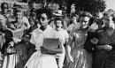15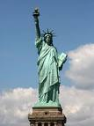16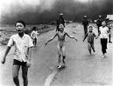
17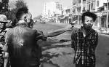 18 19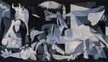
20

